**5V Bus Analysis**

To choose how to power the 5V bus, the current consumption of the array was analyzed. Initially, the on-board regulator of the Arduino Mega was considered. The feasibility of this on-board voltage regulator was analyzed. According to the schematics and datasheets, the voltage regulator for the Arduino Mega can source approximately 500mA [REF1]. The sensor array was estimated to draw a maximum of 200mA per sensor. The total maximum current draw for the entire sensor array was estimated to be 1.6A. As a result, the on-board voltage regulator on the Arduino would not be able to source the necessary current for the sensor array. Two Fairchild Semiconductor LM7805 linear regulators were chosen to create the 5V bus. According to the datasheet, each regulator is capable of sourcing 1A under room temperatures [REF2]. These regulators were installed in parallel. The effect of heat production as a result to dissipating the necessary current within the regulator was investigated since these devices’ output voltages drop with the temperature. To test the thermal characteristics, the sensor arrays were connected to the voltage regulators and the output voltage was monitored. With this experiment the voltage was observed to drop 1mV/second as the components’ temperatures increased. The voltage eventually dropped as low as 4.85V. As a result, a heat sink and active cooling solution would need to be installed with the regulators. After installing the cooling solutions the regulators maintained a constant 4.96V output voltage and remained at room temperature. Below is a figure of the voltage regulators and active cooling solution.

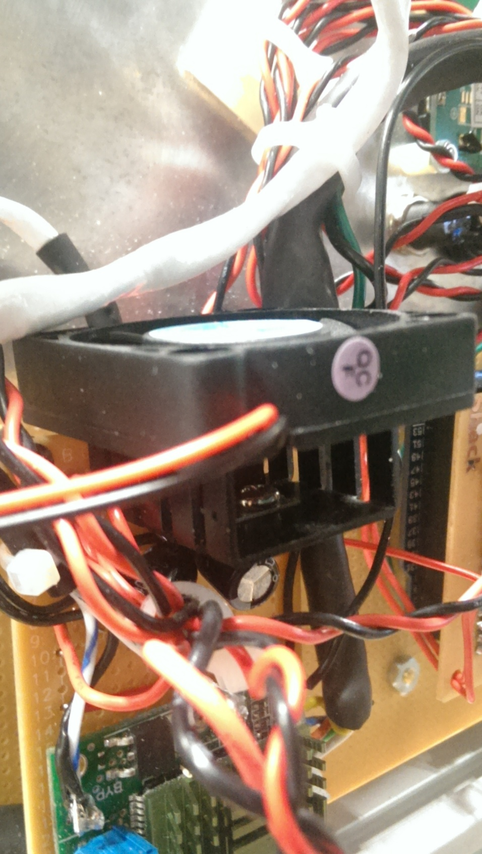

**References**

Arduino (2014). Arduino Mega 2560. Retrieved from: http://arduino.cc/en/Main/arduinoBoardMega2560

Fairchild Semiconductor (2013). LM78XX/LM78XXA 3-Terminal Voltage Regulator. Retrieved from: https://www.fairchildsemi.com/datasheets/LM/LM7805.pdf